General information about the crops
Cucumber (zaid)
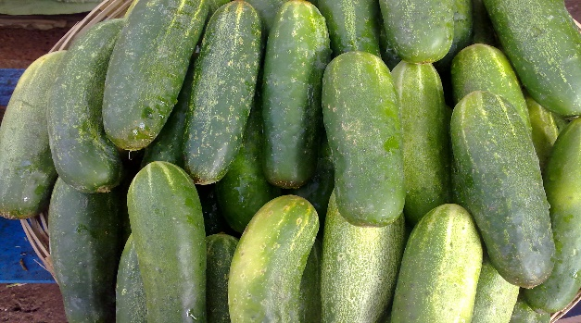
Common name- kheera
- General-
The botanical name of cucumber is Cucumis sativus. Cucumbers are originated in India. It is a climbing plant which is used as summer vegetable throughout in India. The cucumber fruit is eaten raw or is served as a salad or cooked as a vegetable. The seeds of cucumber are used for oil extraction which is good for body and brain. Cucumbers contain 96% water which is good in summer season. The plants are large sized, leaves are hairy and are triangular in shape and owers are yellow in color. Cucumber is an excellent source of Mb (Molybdenum) and Vitamin K. Cucumber is used to cure skin problems, kidney and heart problems and is used as alkalizer.

- Climate
Temp  (MIN/MAX)  25-35 | Rainfall  (MIN/MAX)  12-15 cm
Sowing Temperature  22-30 | Harvesting Temperature  30-35

- Popular variety with their Yield.
Variety | Yield
Pusa uday | 7
Pusa barkha | 7
Pusa navee | 7
Cucumber75 | 16
poinsett | 45-80
Kh 1 | 145-166
Japnaess long green | 16

- Land preparation
For cucumber plantation, it requires well prepared and weed free bed. To bring soil to fine tilth, 3-4 ploughings must be done before planting. FYM such as cow dung is mixed with soil to enrich the beds. Then nursery beds are prepared having width of 2.5m and at the distance of 60cm.

- Sowing- It is sown in the month of February-March.

- Seed Rate- Seed rate of 1.0 kg is sufficent for one acre of land.
Treatment- Before sowing seeds, treat them with the suitable chemical to protect them from disease and pests and to increase viability. Seeds are treated with Captan@2gm before sowing.

Fertilizer Requirement kg/acre
Urea | MOP | DAP
90 | 125 | 35

Nutrient requirement kg /acre
nitrogen | Phosphorus | potash
40 | 20 | 20

At the time of land preparation apply fertilizer dose of Nitrogen @40kg (Urea@90kg), phosphorus @20kg (Single phosphate @125kg) and potassium@20kg (Muriate of potash@35kg) as a basal dose. At the time of sowing, apply one third of the Nitrogen dose along with Potassium and Single superphosphate. At the early stage of veins production i.e. one month of sowing apply rest of the dose
- Weed Control- Weed can be controlled by hand-hoeing and also controlled by chemically, use glyphosate@1.6litre per 150 litre of water. Use glyphosate only on weeds not on crop plants.

- Irrigation- In summer season it requires frequent irrigation and in rainy season it does not require any irrigation. In total it requires 10-12 irrigations. Pre-irrigation is required before sowing then subsequent irrigation is required after 2-3 days of sowing. After second sowing, the crops are then irrigated at the interval of 4-5 days. Drip irrigation is very useful for this crop.

- Plant protection- Anthracnose: It attacks almost all parts of the cucumber which are above the ground. The symptoms are yellowish color circular spots are seen on the older leaves and the circular and sunken spots are seen on the fruit. Treatment: Fungicidal application of Chlorothalonil and benomyl is given to protect the crop from disease.

Bacterial wilt: It is caused by Erwinia tracheiphila. It aects the vascular tissues of the plant which result in immediate wilting. Treatment: Spraying of foliar insecticides is done to cure the bacterial wilt.

Powdery mildew: The symptoms are appearance of white powdery spots on upper surface of leaves which causes leaf withering. Treatment: Application of carbendazim@2gm in 1ltr of water will help to cure powdery mildew. It can also be controlled by fungicidal sprays of Chlorothalonil, benomyl or dinocap.

Mosaic: The symptoms are stunted growth of plant, leaves turn down and fruit knobs become light yellow in color. Treatment: Application of Diazinon is done to cure mosaic disease. Use of Immidachloprid-17.8%SL @7ml in 10ltr of water is done to cure disease.

- Harvesting- Plants start yielding in about 45-50 days after sowing. Mainly 10-12 harvestings can be done. Harvesting is mainly done when the seed of cucumber are soft and the fruits are green and young. Harvesting is done with the help of sharp knife or any sharp object. It gives an average of 33-42qtl/acre of yield.
- Storage

